**Problem 2:**

Implement Stack and Queues using Arrays.

**Solution: -**

**Stack**

class StackProgram

{

static final int max=1000;

int top;

int a[]=new int[max];

boolean isEmpty()

{

return(top<0);

}

StackProgram()

{

top=-1;

}

boolean push(int x)

{

if(top>=(max-1))

{

System.out.println("Stack is overflow");

return false;

}

else

{

a[++top]=x;

System.out.println(x+"pushed into stack");

return true;

}

}

int pop()

{

if(top<0)

{

System.out.println("Stack underflow");

return 0;

}

else

{

int x=a[top--];

return x;

}

}

int peek()

{

if(top<0)

{

System.out.println("Stack underflow");

return 0;

}

else

{

int x=a[top];

return x;

}

}

}

class Stack

{

public static void main(String args[])

{

StackProgram s=new StackProgram();

s.push(10);

s.push(20);

s.push(30);

System.out.println(s.pop()+" Popped from stack");

}

}

**Output: -**

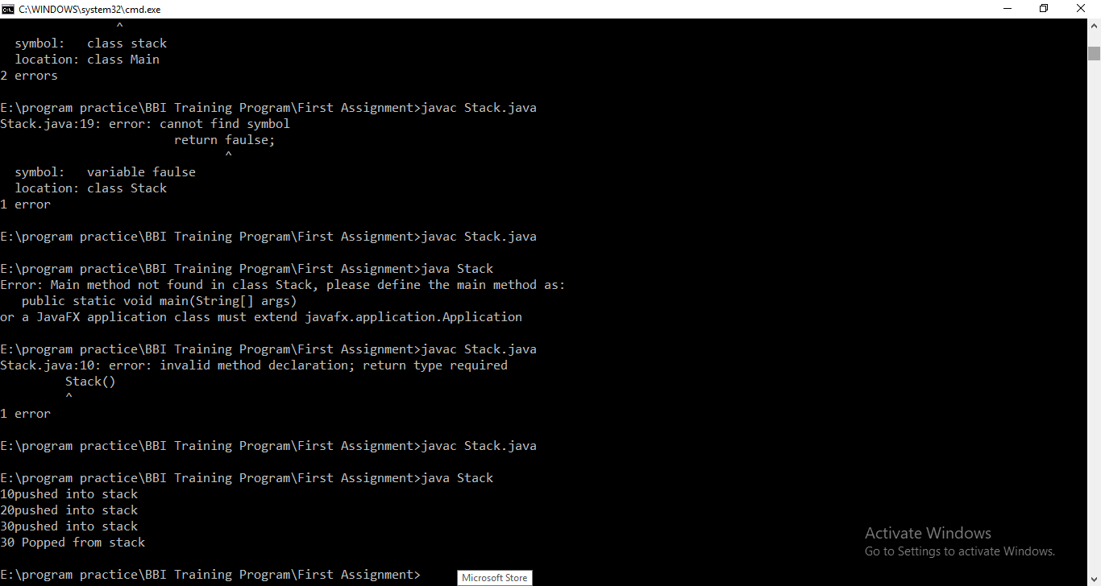

**Queue**

class Queue

{

private static int front,rear,capacity;

private static int queue[];

Queue(int c)

{

front=rear=0;

capacity=c;

queue=new int[capacity];

}

static void queueEnqueue(int data)

{

if(capacity==rear)

{

System.out.println("Queue is full!!!!");

return;

}

else

{

queue[rear]=data;

rear++;

}

return;

}

static void queueDequeue()

{

if(front==rear)

{

System.out.println("Queue is empty!!!");

return;

}

else

{

for(int i=0;i<rear-1;i++)

{

queue[i]=queue[i+1];

}

if(rear<capacity)

queue[rear]=0;

rear--;

}

return;

}

static void queueDisplay()

{

int i;

if(front==rear)

{

System.out.println("Queue is empty!!!");

return;

}

for(i=front;i<rear;i++)

{

System.out.println(queue[i]);

}

return;

}

public static void main(String args[])

{

Queue q=new Queue(4);

System.out.println("After inserting 4 elements in the queue");

q.queueEnqueue(10);

q.queueEnqueue(20);

q.queueEnqueue(30);

q.queueEnqueue(40);

q.queueDisplay();

System.out.println("Try to insert 5th element in the queue");

q.queueEnqueue(50);

System.out.println("Try to display queue after deleting all elements.....");

q.queueDequeue();

q.queueDequeue();

q.queueDequeue();

q.queueDequeue();

q.queueDisplay();

}

}

**Output: -**

